Sentinel Android Tip Driver ™ Features
The following configuration and features instructions take place using version 3.8.2 of the Android TIP Driver being installed on a Janam XG4 using Android Version 11. All future references to the version of the SBS Android Tip Driver will be referencing the version as 3.8.20.6032. Your configuration and features of 3.8.2.xxxx will be very similar if not identical to this one depending upon the version being installed. Version 3.8.20.6032 will be the first release of the new boot strap interface that will be described below.

This procedure assumes that you have already installed the Android Tip Driver.

- To start the Android Tip Driver you must click on the “SBS Tip Driver” icon.
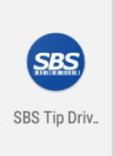

- The first time and only time that you start the Android Tip Driver it will ask you for access permissions. Please respond allow.
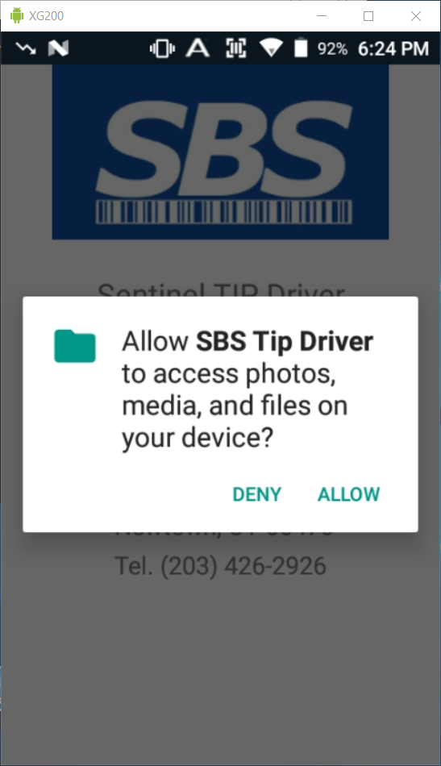

- You will see the splash screen as the TIP Driver loads and then it will dismiss itself without any user intervention and then land on the Sentinel Tip Driver Main Menu. If you would like to dismiss the splash screen immediately long press the SBS Logo.
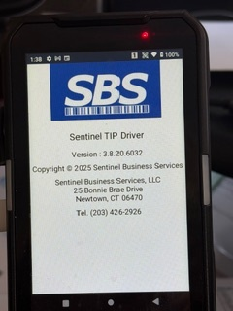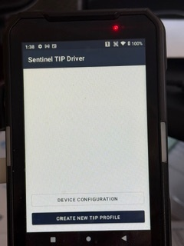
- Before the Android Tip Driver can be used on this device, the “Device Configuration” should be performed. Click on the “Device Configuration” button on the Main Menu and the following screen will be shown;
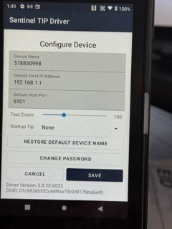
Device Name
The device name is a required entry. A unique default device name will be generated for you. If you choose to not accept this name you must enter a UNIQUE device name.

Default Host IP Address Text Box
This is the hosts (SBS-Pathfinder ™) static IP address that this Android device (client) will use to TCP/IP socket connect to the server that is running the SBS-Pathfinder ™ application. When you setup a new TIP, this will be the default Host IP address shown to you.

Default Host Port Text Box
This is the port # that will be used for the TCP/IP communications. It defaults to Port # 5101 which is the same port # that the SBS-Pathfinder ™ Communications Module defaults todefaults to.

Text Zoom Slider
This value is used to zoom in and out of the size of the text that is displayed in labels, text boxes, buttons etc … We have found that a zoom ratio in the low 90’s simulates the SBS-CASE Tools ™ designer and debugger font. This also assumes that the Android device display settings are set to Font Size = Default and Display Size = Small.

StartUp TIP
Select the TIP project that you would like to start automatically after the splash screen disappears. If you leave the entry as None then the TIP will have to be started manually by pressing START TIP from the Sentinel TIP Driver Main Menu. If you want to change or delete this value after it has been saved, then when you start the TIP driver and see the splash screen, you will need to long press the SBS Logo to return to the main menu screen where you will select “Device Configuration”. Then you will need to change the Startup Tip setting.

Restore Default Device Name
If you changed the device name and you decide that you would like to accept the default device name that was originally generated but you don’t remember what it was, then pressing this button will restore the default device name.

Change Password Button
If the device requires a password to be able to maintain the device configuration or the Tip Profile configuration, then this button will be used to either create or modify a password. When prompted for a password, enter your initial password or change an existing password. If you decide that you no longer want a pass word then changing the password to a space will delete the password. If you forget the password and have no way of retrieving it, call the Sentinel help desk and they will create a special password that will reset it.
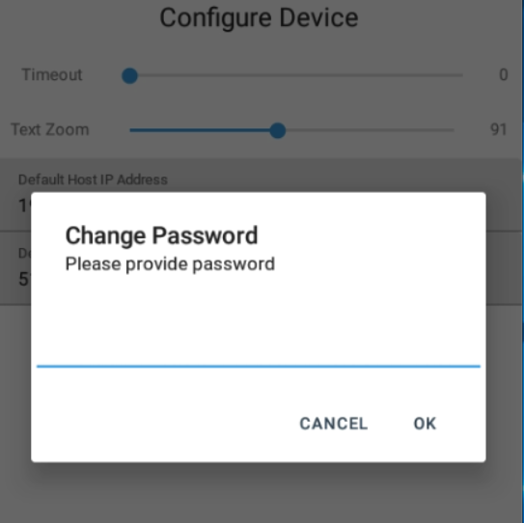

Save Button
Click the “Save” button to update the parameters for the device configuration that you just entered.

Cancel Button
Click the “Cancel” button to NOT update any of the parameters for the device configuration that you just entered.

Data at the bottom of the screen
The data shown is for informational purposes only. It can’t be changed.

- Before the Tip can be used on this device, the “Create New TIP Profile” must be performed. Click on the “Create New TIP Profile” button on the Main Boot Strap Menu and the following screen will be shown;
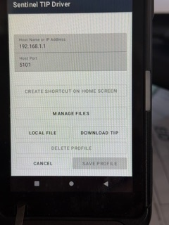
Host IP Address Text Box
This is the hosts (Pathfinder) static IP address that the Android device (client) will use to TCP/IP socket connect to the server that is running the SBS-Pathfinder ™ application. The default Host IP address from the device configuration screen will be shown to you initially. You may accept it (the default address) or change it to a different IP address for this tip. This might be done in an environment with multiple TIP’s talking to multiple SBS-Pathfinder’s ™.

Host Port Text Box
This is the port # that will be used for the TCP/IP communications. It defaults to the Port # entered in the device configuration screen.

Create Shortcut on Home Screen
This button can only be clicked after a TIP has been setup. Once it is clicked you will see the following screen.
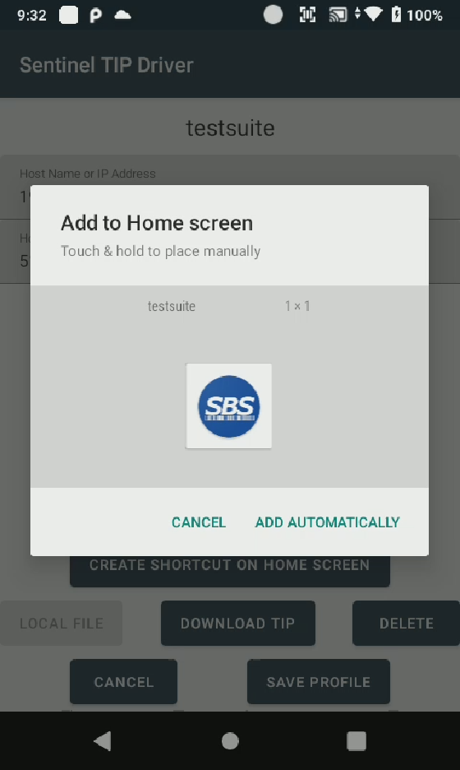
From here you follow the instructions on the screen to either drag the short cut to where you want it or have the system add it to the home screen automatically.

Local File
If the compiled TIP can be found on the Android device then click on the “Local File” and a navigation screen will be shown that will allow you to find and setup that TIP. In this example it is “testsuitexg4”. Select the “testsuitexg4” TIP and that TIP Profile will be setup for you.
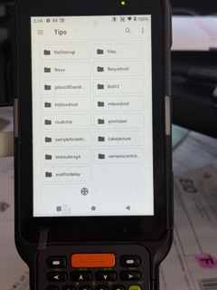

You will either change or accept the default communication configuration parameters. You would then click “Save Profile” to save these changes or “Cancel” to abort the updating of these TIP profile configuration parameters.

Download TIP
If the compiled TIP was imported to Pathfinder then click on the “Download TIP” and a screen will be shown that will allow you to enter the name of the TIP that needs to be setup. In this example it is “Hello World”. Enter the “Hello World” TIP name and the TIP will be downloaded from Pathfinder and a TIP profile will be setup for you. You will notice that it defaults to the IP Address and port # that was entered as parameters into the device configuration section.

Save Profile
Clicking “Save Profile” will save the parameters that were entered for the TIP Profile configuration.

Cancel
Clicking “Cancel” will NOT save the parameters that were entered for the TIP Profile configuration.

Delete
Clicking “Delete” will ask you for a confirmation of the requested delete. Pressing DELETE TIP will delete the entire TIP Profile. The actual TIP file folder SandBox will NOT be deleted.
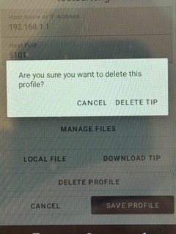

- Once a TIP is setup either from a Local File or a Pathfinder download, you will see it show up in the TIP List. You can either configure or start the TIP by pressing the appropriate button that is associated with the TIP.
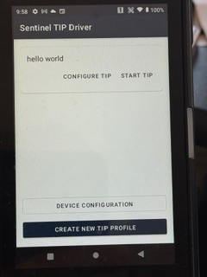

Configure TIP
Clicking “Configure TIP” will ask you to maintain the TIP profile parameters that were previously entered. See “Create New TIP Profile” above for the specific parameters that can be maintained.

Start TIP
Clicking “Start TIP” will start the TIP application.
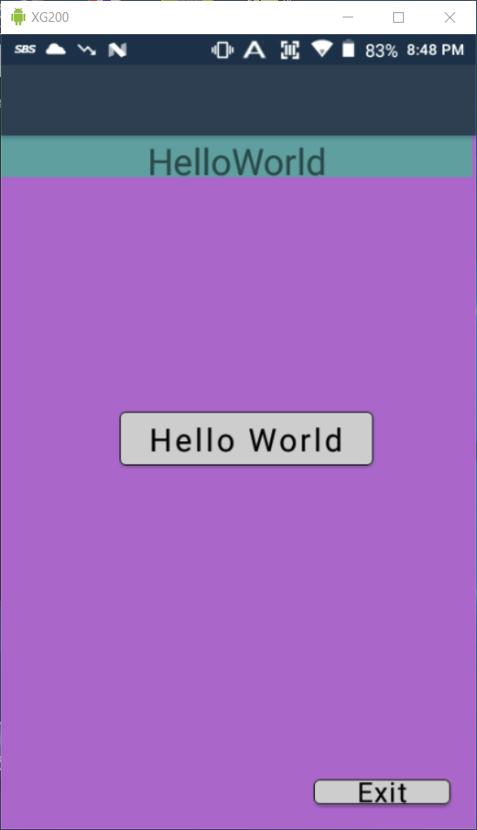

Configure TIP
- If a password was setup then when the “Device Configuration”, “Create New Tip Profile” or the “Configure TIP” buttons are pressed, the operator will be prompted for the password before being allowed into these setup/configuration functions.
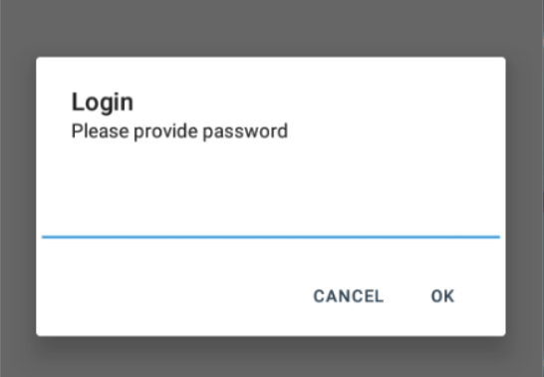

Manage Your SandBox
Android 10, 11 and 13 had many security enhancements in it. A major one was the access to shared storage was restricted which means that access to your sand box of data was restricted. From the CASE Projects perspective if you had written code in a DLL that was part of your project you could no longer sideload it. To compensate for this you can use the Manage Files, Local File and Download TIP buttons to assist you in managing your sandbox.

Manage Files
Pressing this button will show you a list of all files that are eligible to be upload to Pathfinder. Select the file you want and you will be presented with the option to either
    - Upload that file to Pathfinder User Files Folder
    - Delete the file from the SandBox
    - Cancel the requested action on that file

Manage Files
Pressing this button will bring up file explorer. Selection a file from file explorer and that file will be copied into your SandBox.

Download TIP
Pressing this button will ask you to enter the file name and extension of what you would like to download. The default assumption is that you want to download the latest version of the TIP and so it is defaulted for you. Simply click download and the tip will be downloaded. The version of the TIP that was imported to Pathfinders “TIP Programs” will be the version that is downloaded. Enter a valid file name and it will be downloaded from Pathfinder User Files Folder into your SandBox.

